SIMATS ENGINEERING
ASSESSMENT TOOL 2: Case Study

COURSE NAME: COMPUTER VISION COURSE CODE: ITA0518

COURSE OUTCOME COVERED

CO3: Analyze and extract image features using detection and matching techniques for effective image representation and comparison. (BTL 4)

Assessment Tool Weightage: 20%

1.Hough Transform for Shape Detection
A system uses Hough Transform to detect circular shapes but fails in complex backgrounds.
Analyze the limitations and explain how preprocessing or parameter tuning can improve detection.

1. Problem Statement
A computer vision system is designed to detect circular objects in an image using the Hough Circle Transform. However, when the image contains a complex background, the system detects many false circles or misses the actual circles.
Example: Detecting bottle caps in a photograph where the background contains tables, objects, shadows, and patterns.

2. Cause of the Problem
The Hough Transform depends on edge information. In a complex background:
- Many unwanted edges are present.
- Noise creates false circles.
- Shadows may appear as circular edges.
- Objects may overlap.
- Incorrect radius or threshold values can cause missed detections.
- Too many possible circles may be detected.

3. Preprocessing Solution
Before applying the Hough Transform, the image can be preprocessed.
Step 1: Convert to Grayscale
Reduce the image from RGB to grayscale.
Step 2: Apply Gaussian Blur
Remove small noise and unwanted details.
Step 3: Edge Detection
Use an edge detector such as Canny to highlight important boundaries.
Step 4: Remove Background Noise
Morphological operations such as erosion and dilation can help remove unwanted small regions.
Step 5: Apply Hough Circle Transform
Detect circles from the cleaned image.
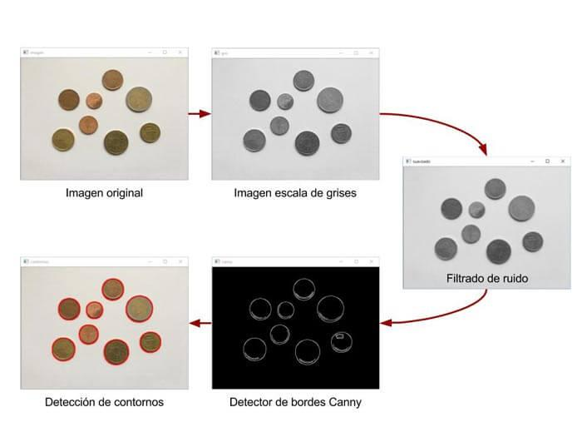
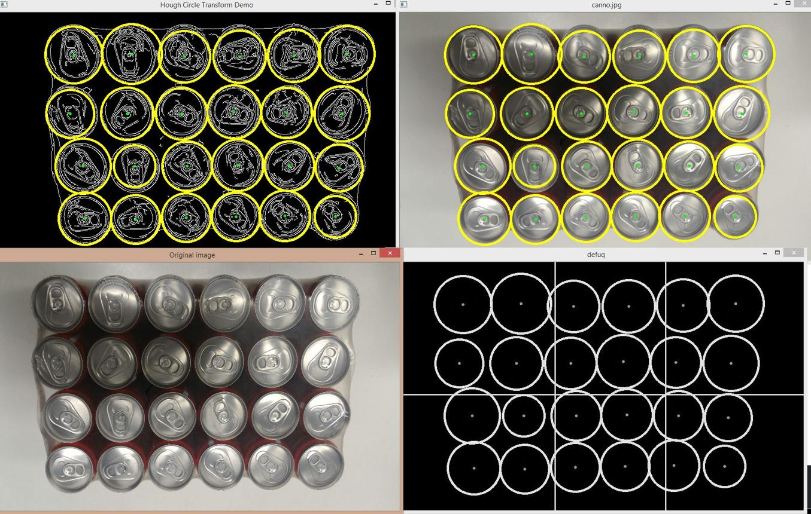
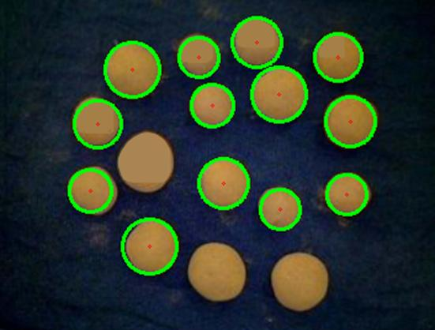
5

4. Parameter Tuning
The accuracy can be improved by adjusting important Hough Transform parameters:
Parameter | Purpose
dp | Controls resolution of the accumulator
minDist | Minimum distance between detected circles
param1 | Canny edge detection threshold
param2 | Threshold for accepting a circle
minRadius | Minimum circle radius
maxRadius | Maximum circle radius
For example, if too many false circles are detected, increase param2.
If actual circles are missing, decrease param2 or adjust the radius range.

5. Result
Before preprocessing:
The system detects many false circles because the complex background contains several edges.
After preprocessing and parameter tuning:
Noise is reduced, unwanted edges are removed, and the Hough Transform detects the required circular objects more accurately.

6. Conclusion
The Hough Transform is effective for detecting circular shapes, but its performance decreases in noisy and complex backgrounds. Applying grayscale conversion, Gaussian filtering, edge detection, and morphological processing, along with proper parameter tuning, can significantly improve circle detection accuracy.

2. Edge Detection in Low Contrast Images
An image has low contrast, causing edge detection algorithms to fail.
Analyze the problem and explain how preprocessing enhances edge detection results.

1. Problem Statement
A computer vision system is used to detect the edges of objects in an image. However, the image has low contrast, so the boundaries between objects and the background are not clearly visible.
Example: Detecting the edges of objects in a medical X-ray image or a dark industrial image.

2. Problem Analysis
In a low-contrast image:
- Object and background have similar intensity.
- Edges are weak and difficult to identify.
- Canny, Sobel, or Prewitt operators may miss important edges.
- Noise can be detected as false edges.
- The final image may contain incomplete boundaries.

3. Preprocessing Methods

Step 1: Grayscale Conversion
Convert the image into grayscale to simplify intensity analysis.

Step 2: Contrast Enhancement
Use Histogram Equalization to improve the difference between dark and bright regions.

Step 3: Noise Removal
Apply Gaussian Blur or Median Filtering to reduce unwanted noise.

Step 4: Edge Detection
Apply an edge detection algorithm such as Canny Edge Detection.

Step 5: Threshold Adjustment
Choose suitable threshold values so that weak but important edges can be detected.
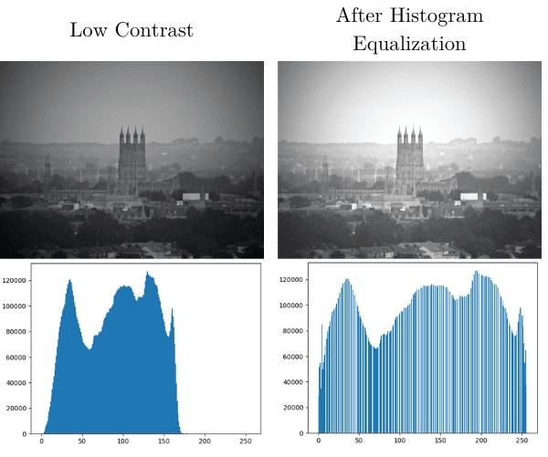
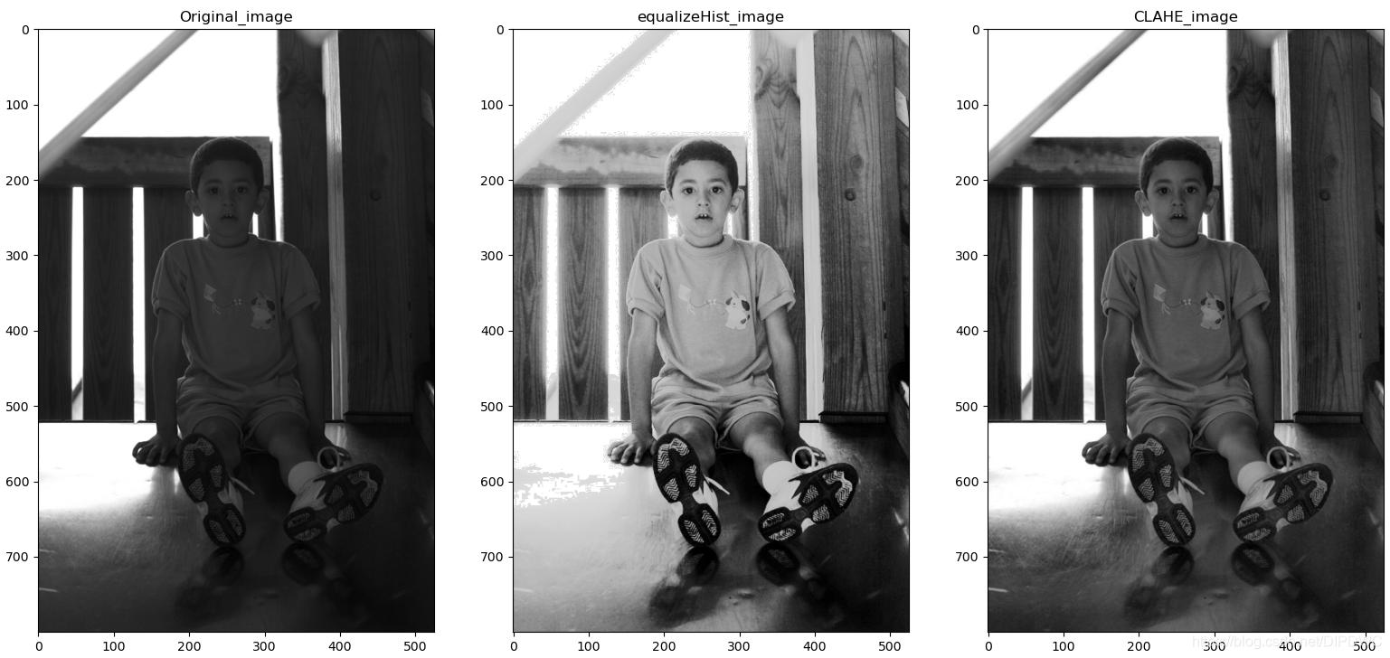
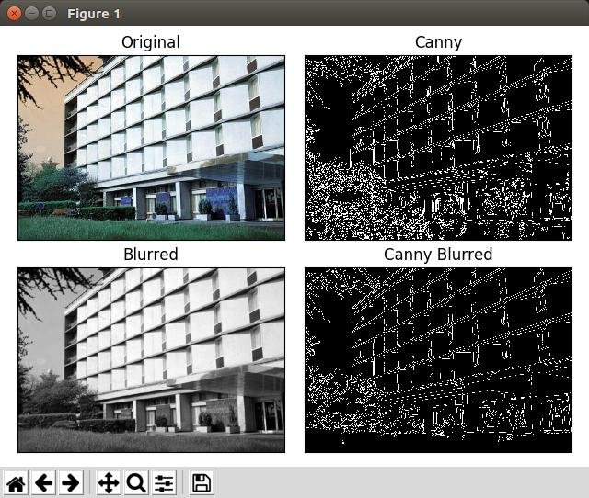
5

4. Example Case
Suppose an industrial inspection system needs to detect cracks on a metal surface.
The original image has very little difference between the crack and the metal surface. Therefore, Canny edge detection produces incomplete edges.
After applying:
Original Image → Grayscale → Histogram Equalization → Noise Filtering → Canny Edge Detection
the crack becomes more visible and its boundary can be detected more clearly.

5. Result
Before Preprocessing | After Preprocessing
Low contrast | Improved contrast
Weak edges | Stronger edges
Missing boundaries | Clearer boundaries
More detection errors | Better edge detection

6. Conclusion
Low contrast reduces the intensity difference between objects and their background, making edge detection difficult. Contrast enhancement, noise reduction, and proper threshold selection improve the visibility of edges and produce more accurate edge detection results.

3.Preprocessing and Feature Detection
A vision system processes images captured under varying lighting conditions. Without preprocessing, feature detection results are inconsistent.
Analyze the issue and explain how preprocessing improves feature detection performance.

1. Problem Statement
A computer vision system is used to detect features such as corners, edges, and key points from images captured under different lighting conditions.
For example, a face recognition system may capture a person's face in bright sunlight, low light, or uneven indoor lighting. Without preprocessing, the detected features may change from one image to another.

2. Problem Analysis
Different lighting conditions can cause:
- Bright or dark regions in the image.
- Loss of important image details.
- Shadows and reflections.
- Changes in image intensity.
- False or missing feature points.
- Inconsistent feature detection.
As a result, algorithms such as SIFT, SURF, ORB, or Harris Corner Detection may produce different results for the same object.

3. Preprocessing Solution
The image can be improved before feature detection.
Step 1: Convert to Grayscale
Reduces the image to intensity information.
Step 2: Noise Reduction
Gaussian or median filtering removes unwanted noise.
Step 3: Contrast Enhancement
Histogram Equalization or CLAHE improves visibility of important features.
Step 4: Brightness Correction
Normalizes images captured under different lighting conditions.
Step 5: Feature Detection
Apply ORB, SIFT, or Harris Corner Detection to the preprocessed image.

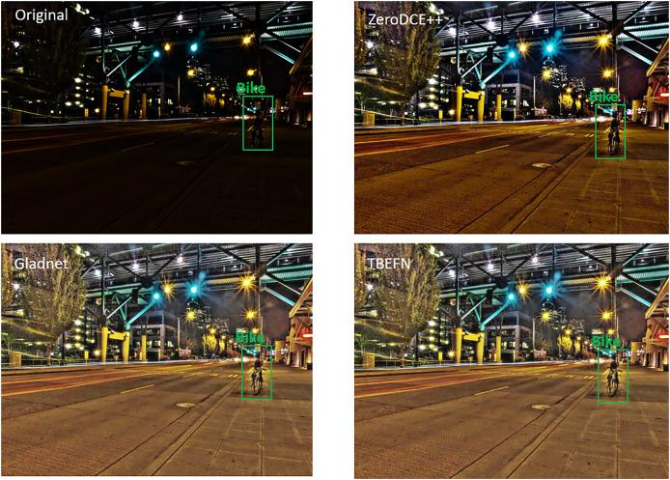

4. Example Case Study
Consider a face recognition system installed at a college entrance.
The camera captures faces at different times of the day. During the morning, the image may be dark, while during the afternoon, strong sunlight may make the image too bright.
Without preprocessing:
- Some facial features are not detected.
- Different numbers of key points are obtained.
- Recognition accuracy decreases.
After preprocessing:
Input Image → Grayscale → Noise Reduction → CLAHE → Feature Detection → Face Recognition
The contrast and brightness become more consistent, allowing the feature detector to identify important facial points more reliably.

5. Result
Without Preprocessing | With Preprocessing
Uneven brightness | More uniform brightness
Features may be missing | More features detected
False key points | Fewer false key points
Inconsistent results | More consistent results
Lower recognition accuracy | Improved recognition accuracy

6. Conclusion
Preprocessing is important when images are captured under different lighting conditions. Grayscale conversion, noise removal, contrast enhancement, and brightness normalization make the image more consistent. This helps feature detection algorithms identify important features more accurately.

4. PCA in Face Recognition
A face recognition system processes high-dimensional image data, resulting in slow performance.
Analyze how PCA helps in reducing dimensionality while preserving important features.

1. Problem Statement
A face recognition system processes face images containing thousands of pixels. Each pixel becomes a feature, resulting in high-dimensional data.
For example, a 100 × 100 pixel grayscale image contains:
100 × 100 = 10,000 features
Processing thousands of features for every face makes the system slower and requires more memory.

2. Problem Analysis
Without dimensionality reduction:
- Large number of features are processed.
- More memory is required.
- Recognition takes more time.
- Some features may contain unnecessary information.
- The system becomes difficult to train.

3. PCA Solution
PCA (Principal Component Analysis) reduces the number of features while retaining the most important information.
The basic process is:
Face Image → Convert to Vector → PCA → Select Principal Components → Face Recognition
PCA finds the directions in the data that contain the maximum variance. These important directions are called principal components.

4. Example Case Study
Consider a college face recognition system containing 1,000 student face images.
Each image is 100 × 100 pixels, giving 10,000 features per image.
Using PCA, the system may reduce these 10,000 features to 100–200 principal components, while preserving the major facial characteristics.
The recognition algorithm then works with these smaller feature vectors instead of the original 10,000-dimensional vectors.

5. How PCA Improves Performance
Without PCA | With PCA
Thousands of features | Fewer principal components
High memory usage | Lower memory usage
Slower processing | Faster processing
Redundant information | Important information retained
Complex computation | Simpler computation

6. Important Point
PCA does not simply select individual pixels. It creates new features called principal components, which are combinations of the original pixel values.
These components represent important patterns such as facial structure, shape, and intensity variations.

7. Result
For example:
Original: 10,000 pixel features
⬇️
PCA: 150 principal components
⬇️
Recognition: Faster face matching
The exact number of components depends on how much variance the system needs to preserve.

8. Conclusion
PCA is useful in face recognition because it reduces high-dimensional image data into a smaller set of important features. This reduces memory usage and computation time while retaining the major information needed for recognizing faces.

9. Feature Matching under Illumination Changes
Two images of the same scene are captured under different lighting conditions,
Analyze why matching fails and explain how preprocessing or robust descriptors improve performance.

1. Problem Statement
A computer vision system needs to match two images of the same scene, but the images are captured under different lighting conditions.
For example, a building may be photographed once during the day and once in the evening. Although the scene is the same, the brightness and shadows are different, causing feature matching errors.

2. Problem Analysis
Feature matching can fail because:
- Brightness changes between images.
- Shadows appear in different locations.
- Some details become darker or brighter.
- Pixel intensity values change.
- Some feature points may disappear.
- Simple descriptors may treat the same feature as different.
As a result, the system may produce incorrect matches or miss correct matches.

3. Preprocessing Solution
Preprocessing can reduce the effect of illumination changes.
Step 1: Convert to Grayscale
Reduces the effect of color and simplifies intensity processing.
Step 2: Contrast Normalization
Makes brightness levels more consistent between images.
Step 3: Histogram Equalization / CLAHE
Improves details in dark and bright regions.
Step 4: Noise Reduction
Gaussian or median filtering removes unwanted noise.
Step 5: Feature Detection and Matching
Use robust feature detectors and descriptors such as SIFT or ORB.
Process:
Input Images → Grayscale → Contrast Normalization → Feature Detection → Robust Descriptor → Feature Matching

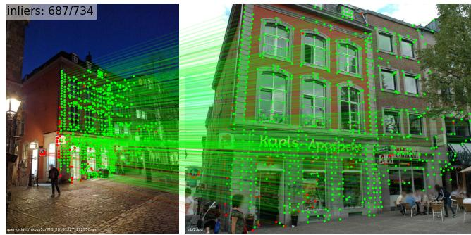

4. Example Case Study
Consider a surveillance system that compares images from a security camera.
The same person or building may appear:
- In bright daylight.
- In cloudy conditions.
- At night.
- Under artificial lighting.
Without preprocessing, the feature descriptors may be different because of changes in brightness and shadows.
After applying CLAHE and grayscale conversion, the important structural details become more consistent. Using a robust descriptor such as SIFT further improves matching because SIFT is relatively resistant to changes in illumination, scale, and rotation.

5. Result
Without Improvement | With Preprocessing & Robust Descriptors
Many incorrect matches | More correct matches
Some features are missed | Important features are retained
Sensitive to brightness | More resistant to lighting changes
Low matching accuracy | Improved matching accuracy
Unstable results | More consistent results

6. Conclusion
Illumination changes modify the appearance of features even when the actual scene remains unchanged. Grayscale conversion, contrast normalization, CLAHE, and noise reduction can reduce these effects. Using robust descriptors such as SIFT or ORB further improves feature matching performance.

